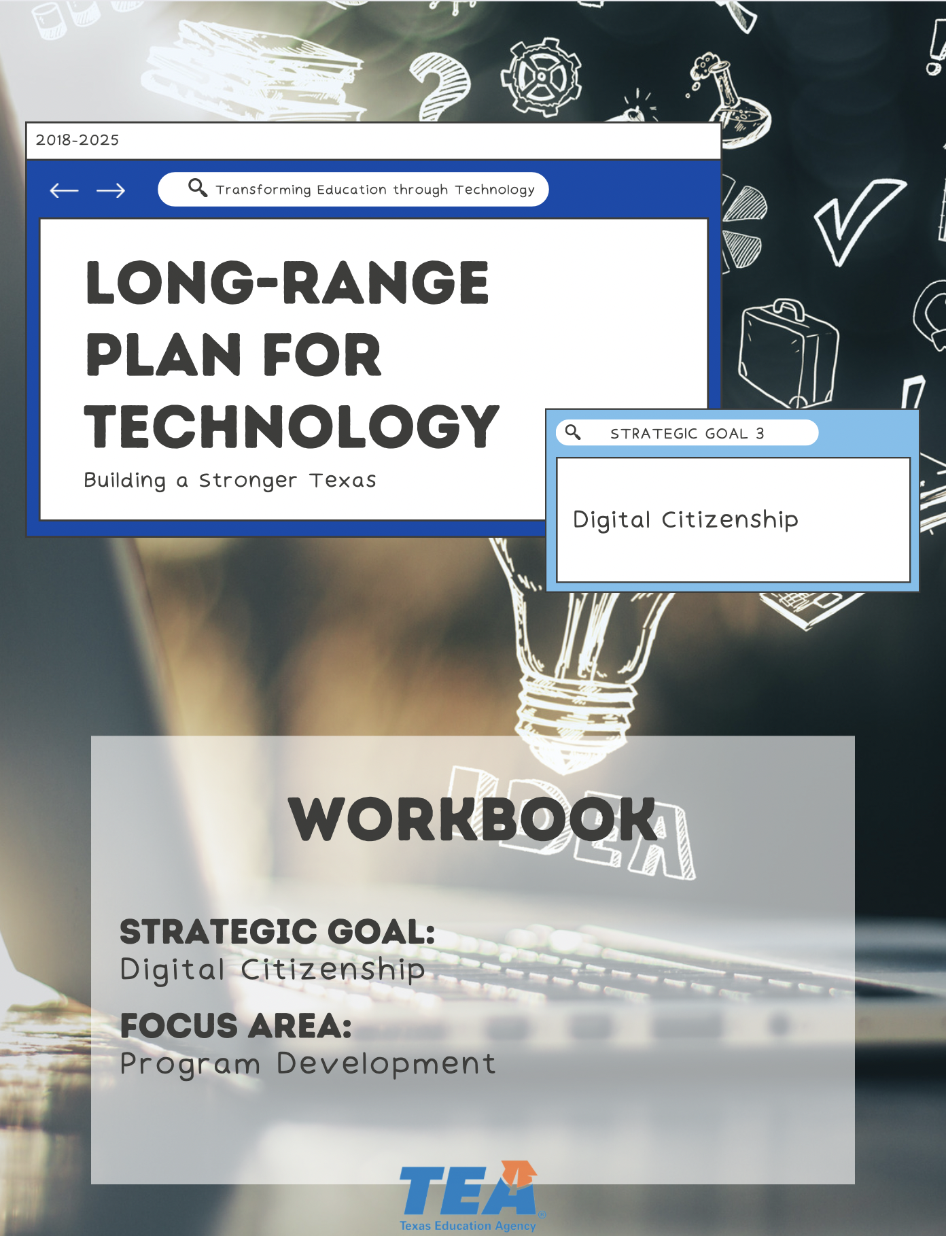

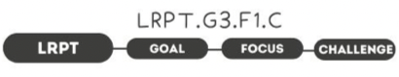

1. Take Note & Reflect:
How does your district define acceptable use of technology?

2. Take Note & Reflect:
Once you set these standards for acceptable use and digital citizenship, how are you then able to measure their effectiveness? What would this look like for your district?

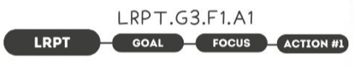

1. Take Note & Reflect:
Reflect on your district’s digital citizenship standards. Write down some examples of how you address both the intake and output for the digital environment.

2. Take Note & Reflect:
Reflect on how these standards are shared with your community. How are you sharing these standards?

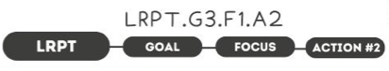

1. Take Note & Reflect:
Take a moment and reflect on how you are currently measuring outcomes in your district. What method are you using or would like to utilize in the future?

2. Take Note & Reflect:
How will you gather data? After measuring effectiveness, how are you planning to use the results for your district?

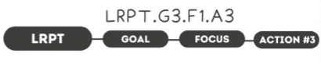

1. Take Note & Reflect:
How is your district planning to monitor and update programs?

2. Take Note & Reflect:
Reflect on technology changes. How will your district remain aware of technology changes and what plan is or will be put in place to update programs?

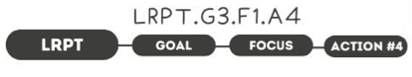

1. Take Note & Reflect:
How are you balancing responsibility and protection for your learners? How are you encouraging and teaching critical thinking and 'filtering' off input?

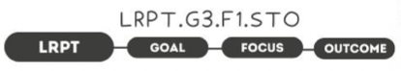

1. Take Note & Reflect:
How would you define a responsible digital citizen for your district?

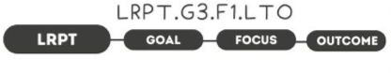

1. Take Note & Reflect:
Reflect on what a responsible student population would look like at your school. What does responsibility for digital actions, behaviors, consequences look like? How will you measure this in your district?

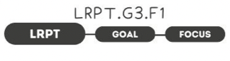

1. Take Note & Reflect:
Write a short summary statement for this focus area. How would you summarize what you've done and what you need to do for this focus area based on your work so far?

