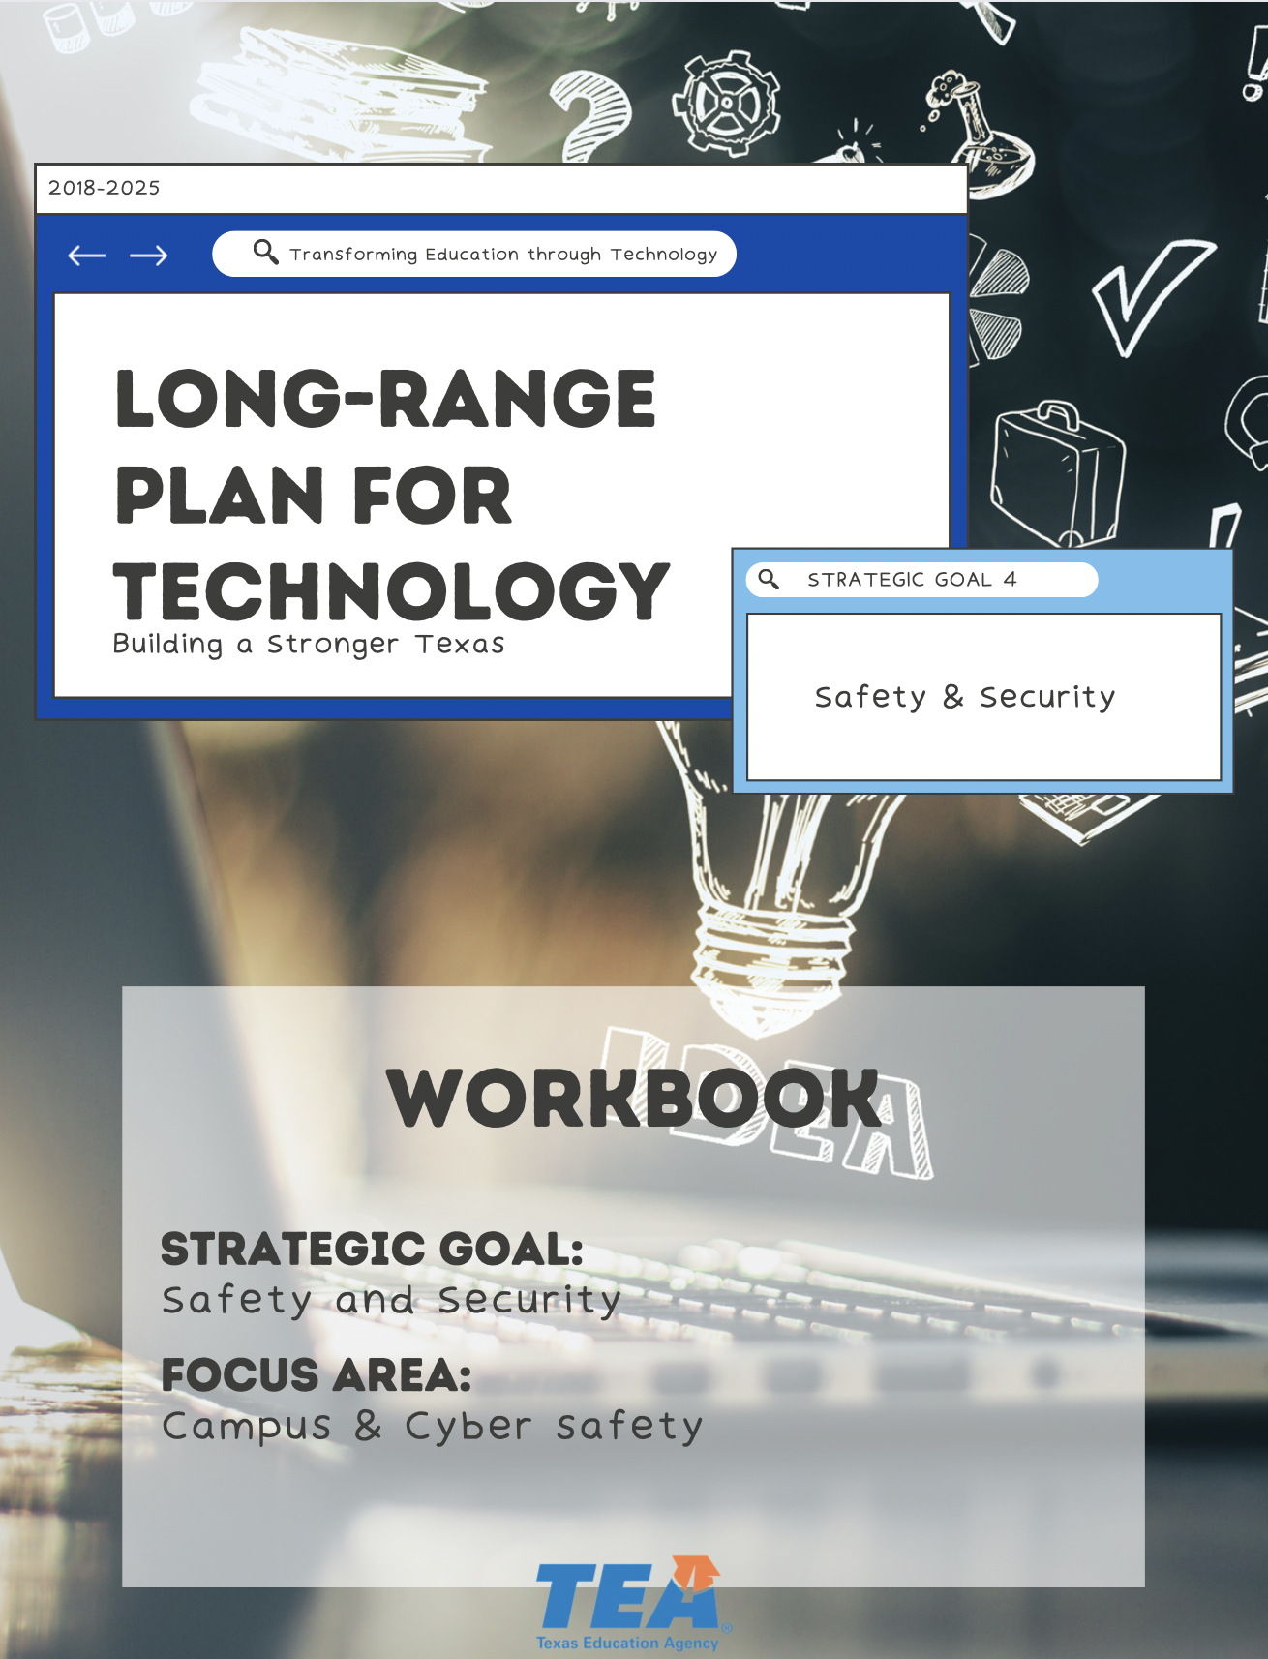

1. Take Note & Reflect:
Reflect on how you meet the basic needs of your students' safety and security. Are you meeting these needs in the virtual space?

1. Take Note & Reflect:
Review the Texas School Safety Center guidelines. How is your school safety plan inclusive of this?

2. Take Note & Reflect:
Review the Cyber Safety Considerations for K-12 Schools and School Districts. Is your school aligned with this?

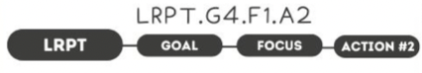

1. Take Note & Reflect:
Reflect on how you are currently using the resources at the Texas School Safety Center. How will you continue to utilize these resources for your schools safety development?

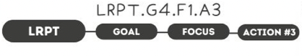

1. Take Note & Reflect:
What technology are you using to enhance safety solutions? How will you continue to develop in this area?

2. Take Note & Reflect:
Reflect on how you protect the data you have and the future data you collect. Do your plans include space for availability, maintenance, and guidelines for media storage?

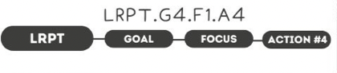

1. Take Note & Reflect:
How are you currently leveraging these types of funding programs?

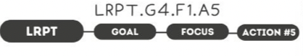

1. Take Note & Reflect:
What policies does your district have on responsible use for all devices, networks, and systems for students and staff?

2. Take Note & Reflect:
Reflect on the policies your district has on responsible use for all devices, networks, and systems for students and staff. How are you promoting these policies? Do all your policies include adherence to the Children's Internet Protection Act (CIPA)?

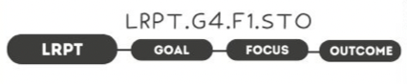

1. Take Note & Reflect:
What tools do you use to promote safety and how you measure their effectiveness?

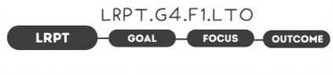

1. Take Note & Reflect:
When a school campus or learning environment is free from risk or harm, what replaces the concern (creativity, autonomy, etc.)?

1. Take Note & Reflect:
Write a short summary statement for this focus area. How would you summarize what you've done and what you need to do for this focus area based on your work so far?

