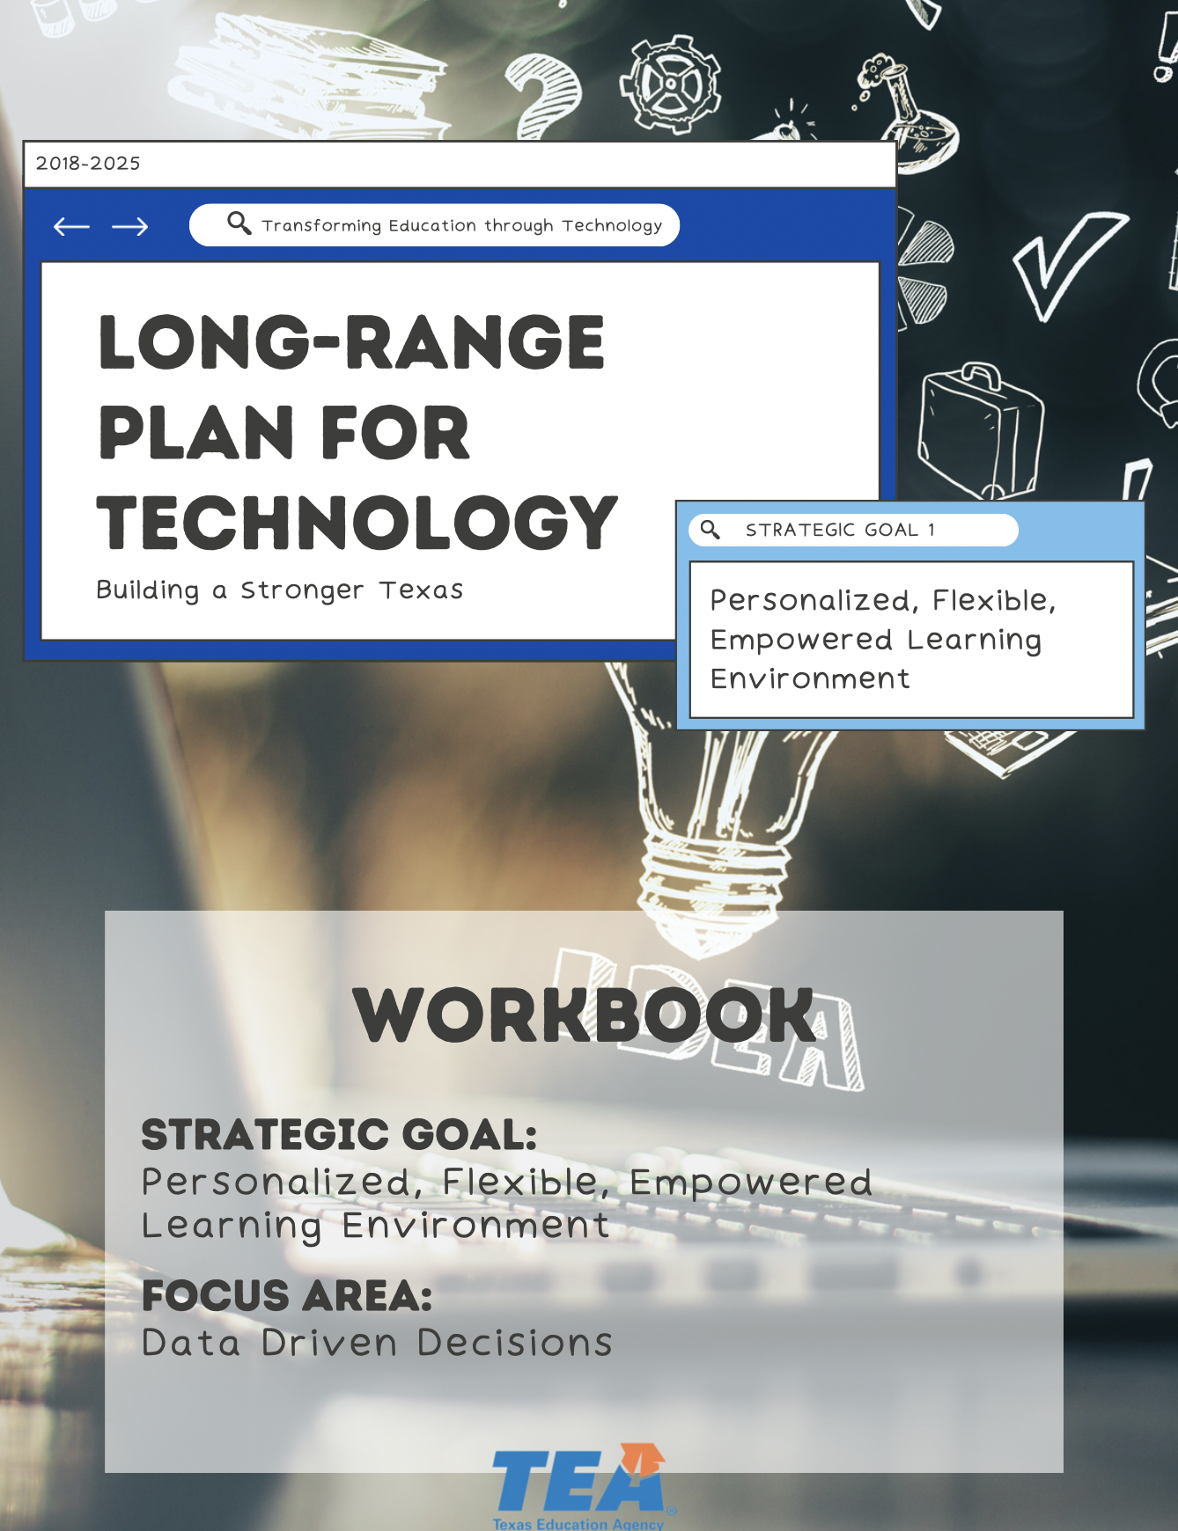

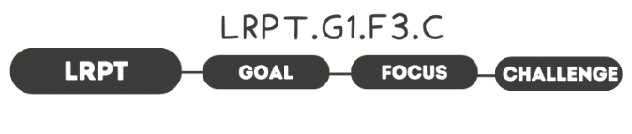

1. Take Note & Reflect:
Reflect on the current data management and governance in your district. What data are you collecting and how are you storing & using your data?

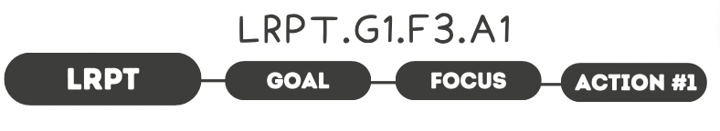

1. Take Note & Reflect:
Reflect on important and useful data in your district. How does data impact decisions made in your district?

2. Take Note & Reflect:
What student information system do you have in place in your district?

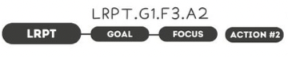

1. Take Note & Reflect:
Reflecting on what is actionable data, what information do you regularly collect within your district?

2. Take Note & Reflect:
How is data made available to teachers? What technology are you using to enable teachers to meet goals in their classroom?

3. Take Note & Reflect:
Reflect on what a course correction could look like for a student that uses dynamic data, readily-available to teachers.

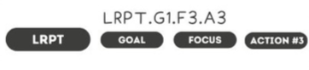

1. Take Note & Reflect:
What is your strategic plan for data use and how are you using it to drive decision-making? Review your strategic plan for data use or begin brainstorming the creation of this plan for your district.

2. Take Note & Reflect:
What data will be your focus and how will it be used?

3. Take Note & Reflect:
What would be included in PD for staff to utilize data to drive educational decisions?

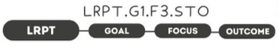

1. Take Note & Reflect:
What would greater insight for data driven decisions allow in your district?

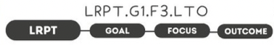

1. Take Note & Reflect:
What does a more efficient use of time and resources look like for your district? What does improved student instruction look like?

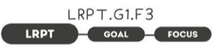

Take Note & Reflect:
Write a short summary statement for this focus area. How would you summarize what you've done and what you need to do for this focus area based on your work so far?

