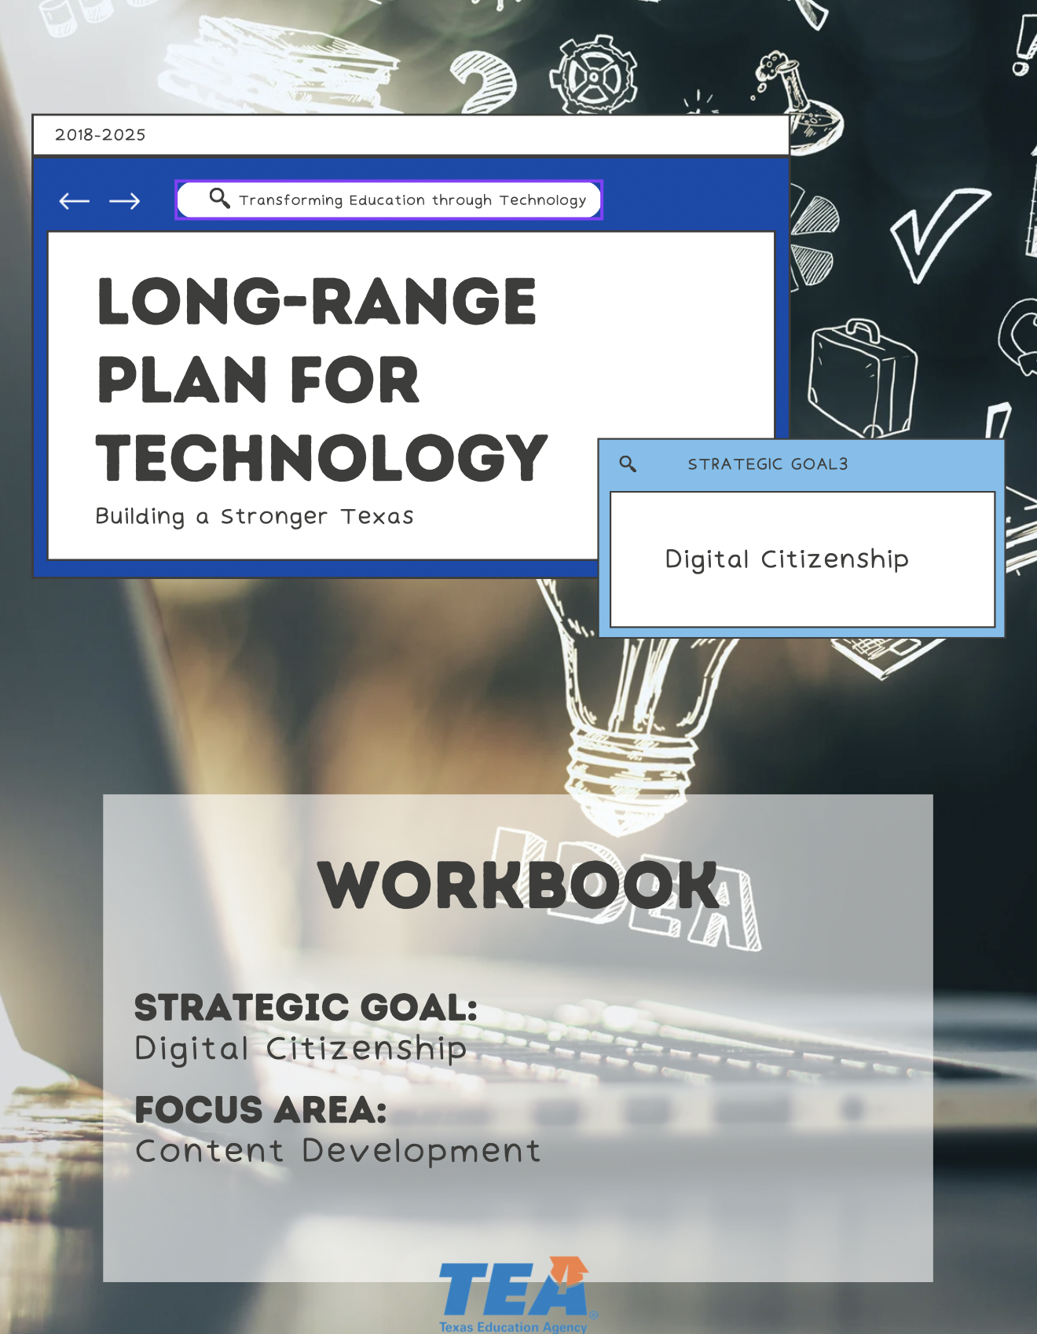

1. Take Note & Reflect:
Reflect on what a digital footprint includes for your student population. What are you already doing to promote understanding?

1. Take Note & Reflect:
What existing training and awareness resources are you using in your district?

2. Take Note & Reflect:
Reflect on the most effective ways you can engage with learners with this training. How are you already engaging with them?

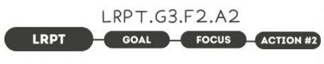

1. Take Note & Reflect:
Reflect on incorporating digital citizenship into the curriculum. How is the consistent practice of exploring digital citizenship in a safe environment being incorporated in your district?

2. Take Note & Reflect:
How could your district utilize the THINK acronym when making decisions about engaging in the digital world?

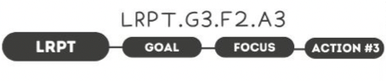

1. Take Note & Reflect:
How is the consistent practice of exploring digital citizenship in a safe environment being incorporated in your district? Do your current lessons hold space for expanding digital citizenship conversations in your district?

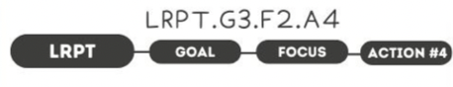

1. Take Note & Reflect:
How are staff, teachers, and parents being encouraged and supported to lead by example in showcasing responsible digital practices?

2. Take Note & Reflect:
How do your parents/teachers/staff know what behavior to model?

1. Take Note & Reflect:
What doesn't exist inside of positive school culture? How do you currently create Positive School Culture in your district?

2. Take Note & Reflect:
Reflect on what positive school culture looks like in your district. How are staff, teachers, and parents being encouraged and supported to lead by example in showcasing responsible digital practices?

1. Take Note & Reflect:
Reflect on your districts vision of a tech-savvy student population. What traits would these students have? What tools would they need starting now?

1. Take Note & Reflect:
Write a short summary statement for this focus area. How would you summarize what you've done and what you need to do for this focus area based on your work so far?

