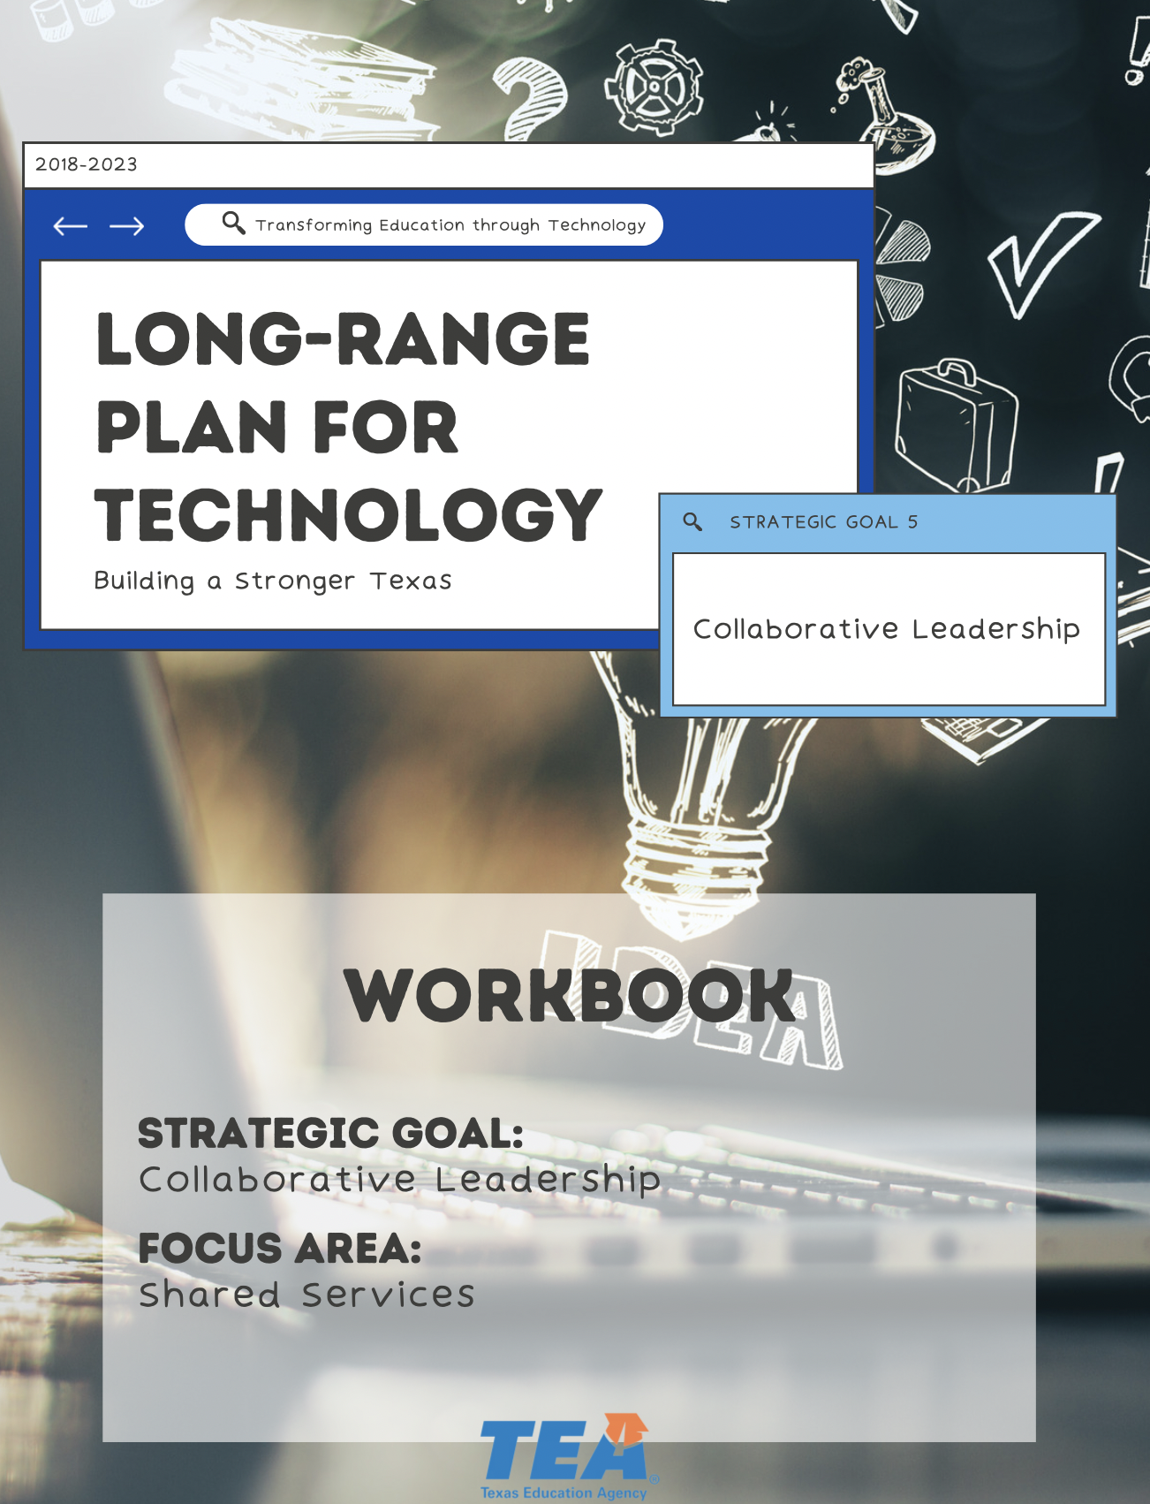

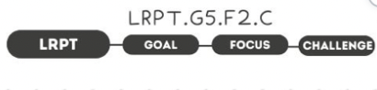

1. Take Note & Reflect:
What does your current shared service model look like?

2. Take Note & Reflect:
What are your challenges around operational governance and staffing for system maintenance?

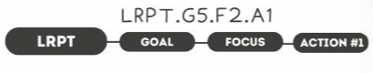

1. Take Note & Reflect:
What existing shared services/freemium programs have been effective in other education service centers or organizations? Who could you find out more about existing shared services from?

2. Take Note & Reflect:
What ideas for new models have you explored for additional cost savings?

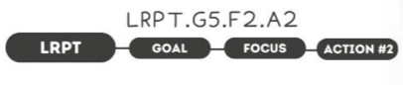

1. Take Note & Reflect:
What shared service models can be developed based on business values?

2. Take Note & Reflect:
How are you developing shared service models that reflect your values and promote a consistent IT landscape?

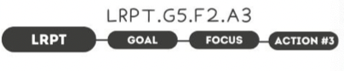

1. Take Note & Reflect:
What does executive support for IT governance look like in your district? How would this allow you to continually develop and deploy shared service solutions?

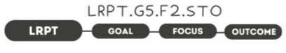

1. Take Note & Reflect:
What would improved customer relations look like in your district?

2. Take Note & Reflect:
How could cost savings enable you to reach other district goals?

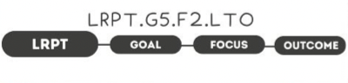

1. Take Note & Reflect:
What would IT leaders focusing on mission rather than IT admin allow the district to experience?

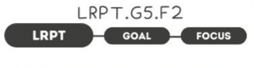

1. Take Note & Reflect:
Write a short summary statement for this focus area. How would you summarize what you've done and what you need to do for this focus area based on your work so far?

