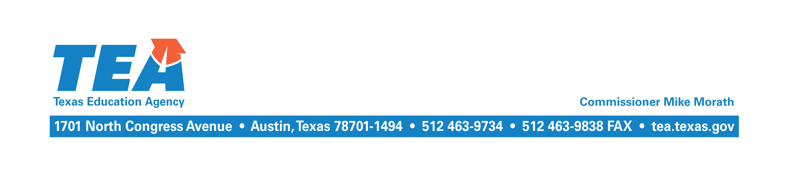

September 13, 2016

To the Adminstrator Addressed:

Subject: 2015–2016 Near-Final Chapter 41 Recapture

The Near-Final Cost of Recapture (COR) report and other related reports for the 2015–2016 school year have been updated and are available at the School District State Aid Reports website at https://tea4avfawcett.tea.state.tx.us/fsp/Reports/ReportSelection.aspx. The Near-Final COR report incorporates the final calculation of Chapter 41 WADA that reflects the student attendance data submitted by your district through the Public Education Information Management System (PEIMS) in summer 2016 for the 2015–2016 school year, and any other corrections or updates that are necessary.

The maintenance and operations (M&O) tax collections your district reported through the Tax Information Survey subsystem of the Foundation School Program (FSP) System in summer 2016 have also been used. If your district did not complete the survey, then budgeted tax collections for the 2015–2016 school year as reported through the PEIMS will continue to be used until tax collections reported in the J-1 schedule of the 2015−2016 annual financial report are incorporated at Final settle up in April 2017.

Your district has a balance due for the 2015–2016 school year. Enter your district’s name or number and select school year 2015–2016 from the drop down menu at the following link to view your outstanding balance: https://tea4avfawcett.tea.state.tx.us/fsp/Payments/Ledger.aspx. The payment should be made electronically using the standard wiring instructions. Please indicate the district name and the appropriate school year on the reference line.

If you have any questions about this letter, please contact Kim Wall by email at kim.wall@tea.texas.gov or by phone at (512) 463-4809.

Sincerely,

Al McKenzie
Director of State Funding

AM/kw

