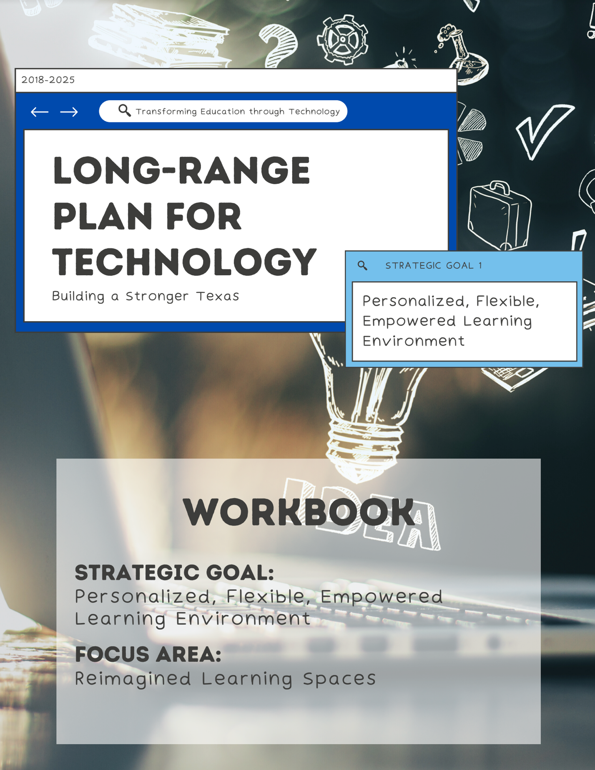

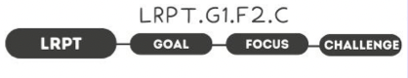

1. Take Note & Reflect:
What would you define are the requirements for a traditional classroom?

2. Take Note & Reflect:
What type of collaboration, movement, and autonomy do you already have in your classrooms?

3. Take Note & Reflect:
What are some ways virtual learning has created the opportunity for expanded learning? What does meaningful understanding look like in your district?

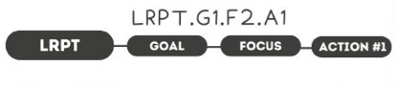

1. Take Note & Reflect:
What does a current physical classroom look like? What are some of the ways students show up in 'redesigned' classrooms? (Home, outdoors, etc.)

2. Take Note & Reflect:
How are you currently creating 'active learning spaces'? How are you ensuring power, connectivity, and technology resources are always available? Take a minute to evaluate how you are maintaining accessibility to these spaces.

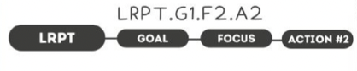

1. Take Note & Reflect:
Reflect on what online resources you use in your district. What would you like to see more of? Do you use any open education resources (OER) in your district?

2. Take Note & Reflect:
How do you collaborate with your technology curriculum team? What professional development practices are in place (or you would like to put in place) for virtual learning?

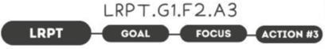

1. Take Note & Reflect:
How are you enabling student agency? How are students making decisions about their learning environments? Are students being encouraged to understand what is 'best' for them when they try new things?

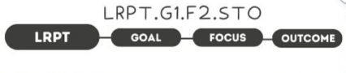

1. Take Note & Reflect:
What does a positive, flexible learning space look like for your district?

2. Take Note & Reflect:
What are some example of integrated technology in your district? How are you continuing to grow these practices and measuring effectiveness?

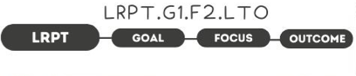

1. Take Note & Reflect:
What does a classroom that fosters creativity look like in your district? How do students measure what is working for them?

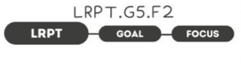

1. Take Note & Reflect:
Write a short summary statement for this focus area. How would you summarize what you've done and what you need to do for this focus area based on your work so far?

