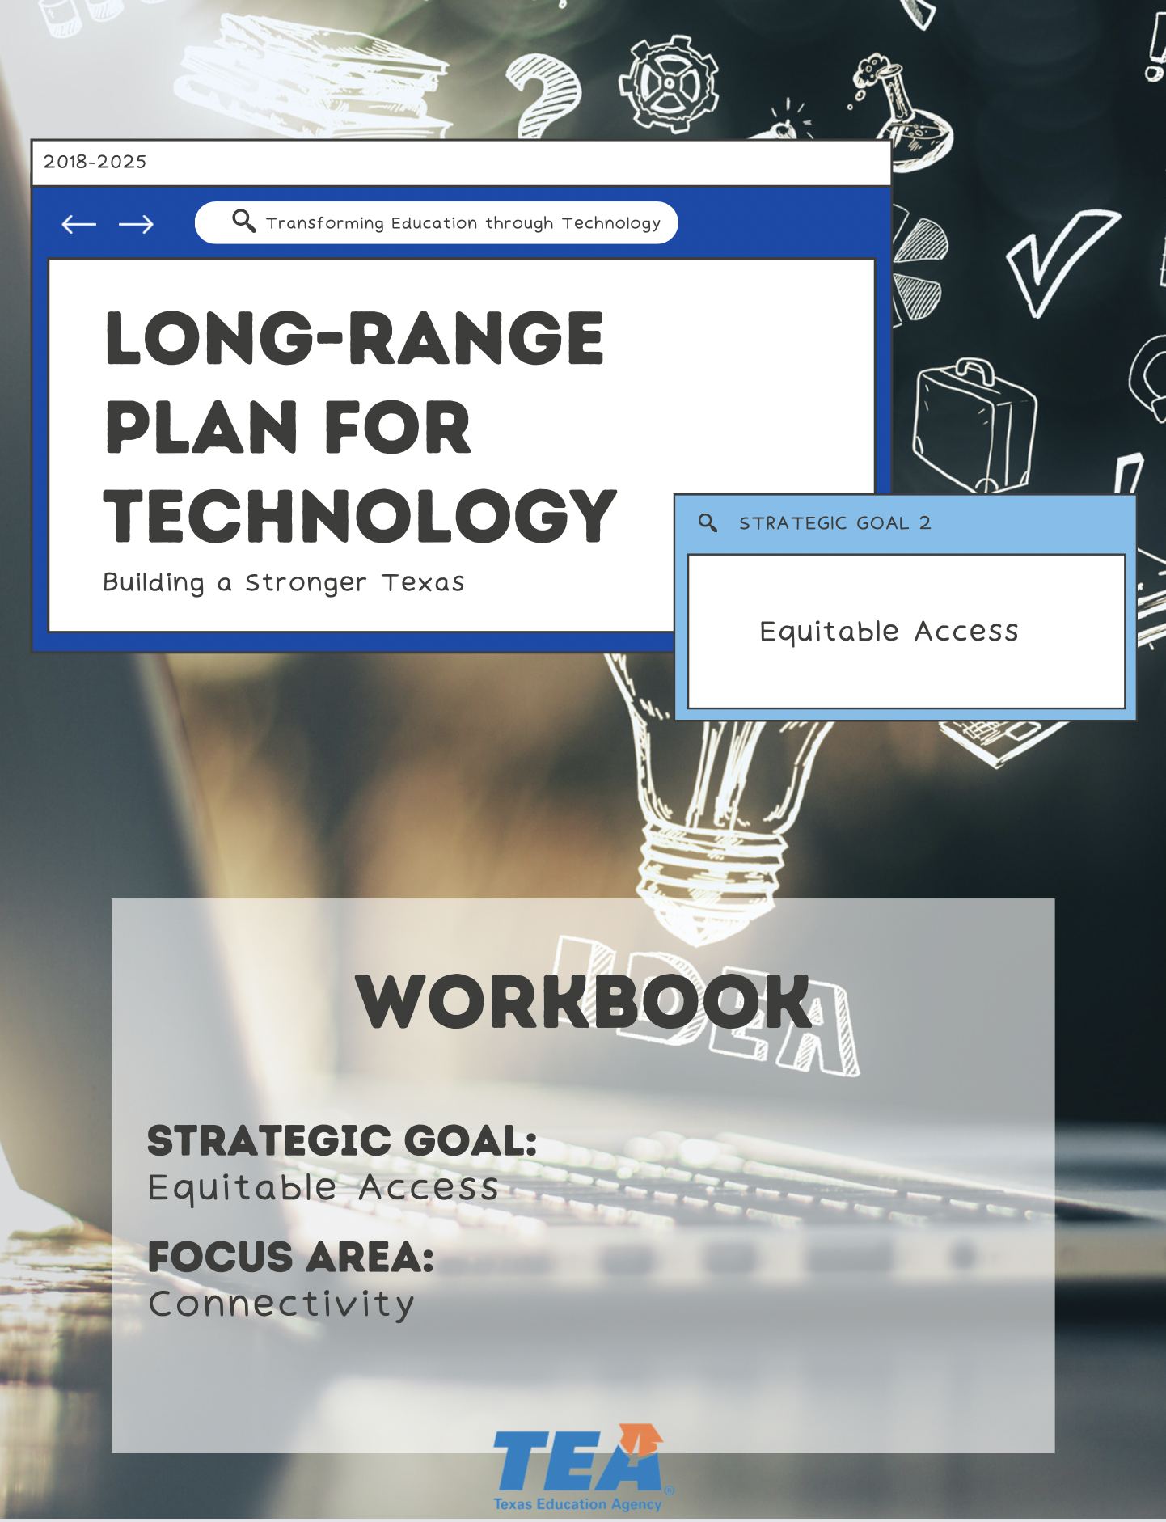

1. Take Note & Reflect:
Use this space to reflect on what connectivity looks like in your district. What are the challenges your district has faced with limited connectivity?

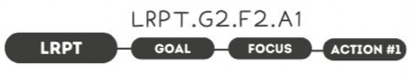

1. Take Note & Reflect:
Reflect on the work you have already done with local education centers and internet service providers. What has already been done or preparing to be done?

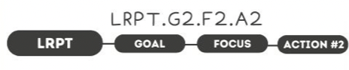

1. Take Note & Reflect:
What is your district doing to collect information on student needs? How can you use this information to better serve your district?

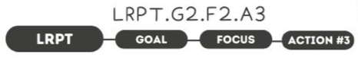

1. Take Note & Reflect:
Reflect on how you have been leveraging available programs for student needs. How will you continue to do so?

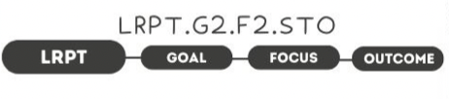

1. Take Note & Reflect:
What does resilient infrastructure look like in your district? What does increased productivity look like for your students?

2. Take Note & Reflect:
Reflect on increased productivity in your district. How can you get there sustainably?

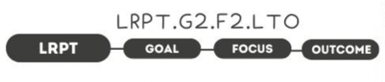

1. Take Note & Reflect:
What would 24/7 access that was affordable and scalable look like for your district? What instructional resources would make the biggest impact to your students and teachers if they were always accessible?

1. Take Note & Reflect:
Write a short summary statement for this focus area. How would you summarize what you've done and what you need to do for this focus area based on your work so far?

