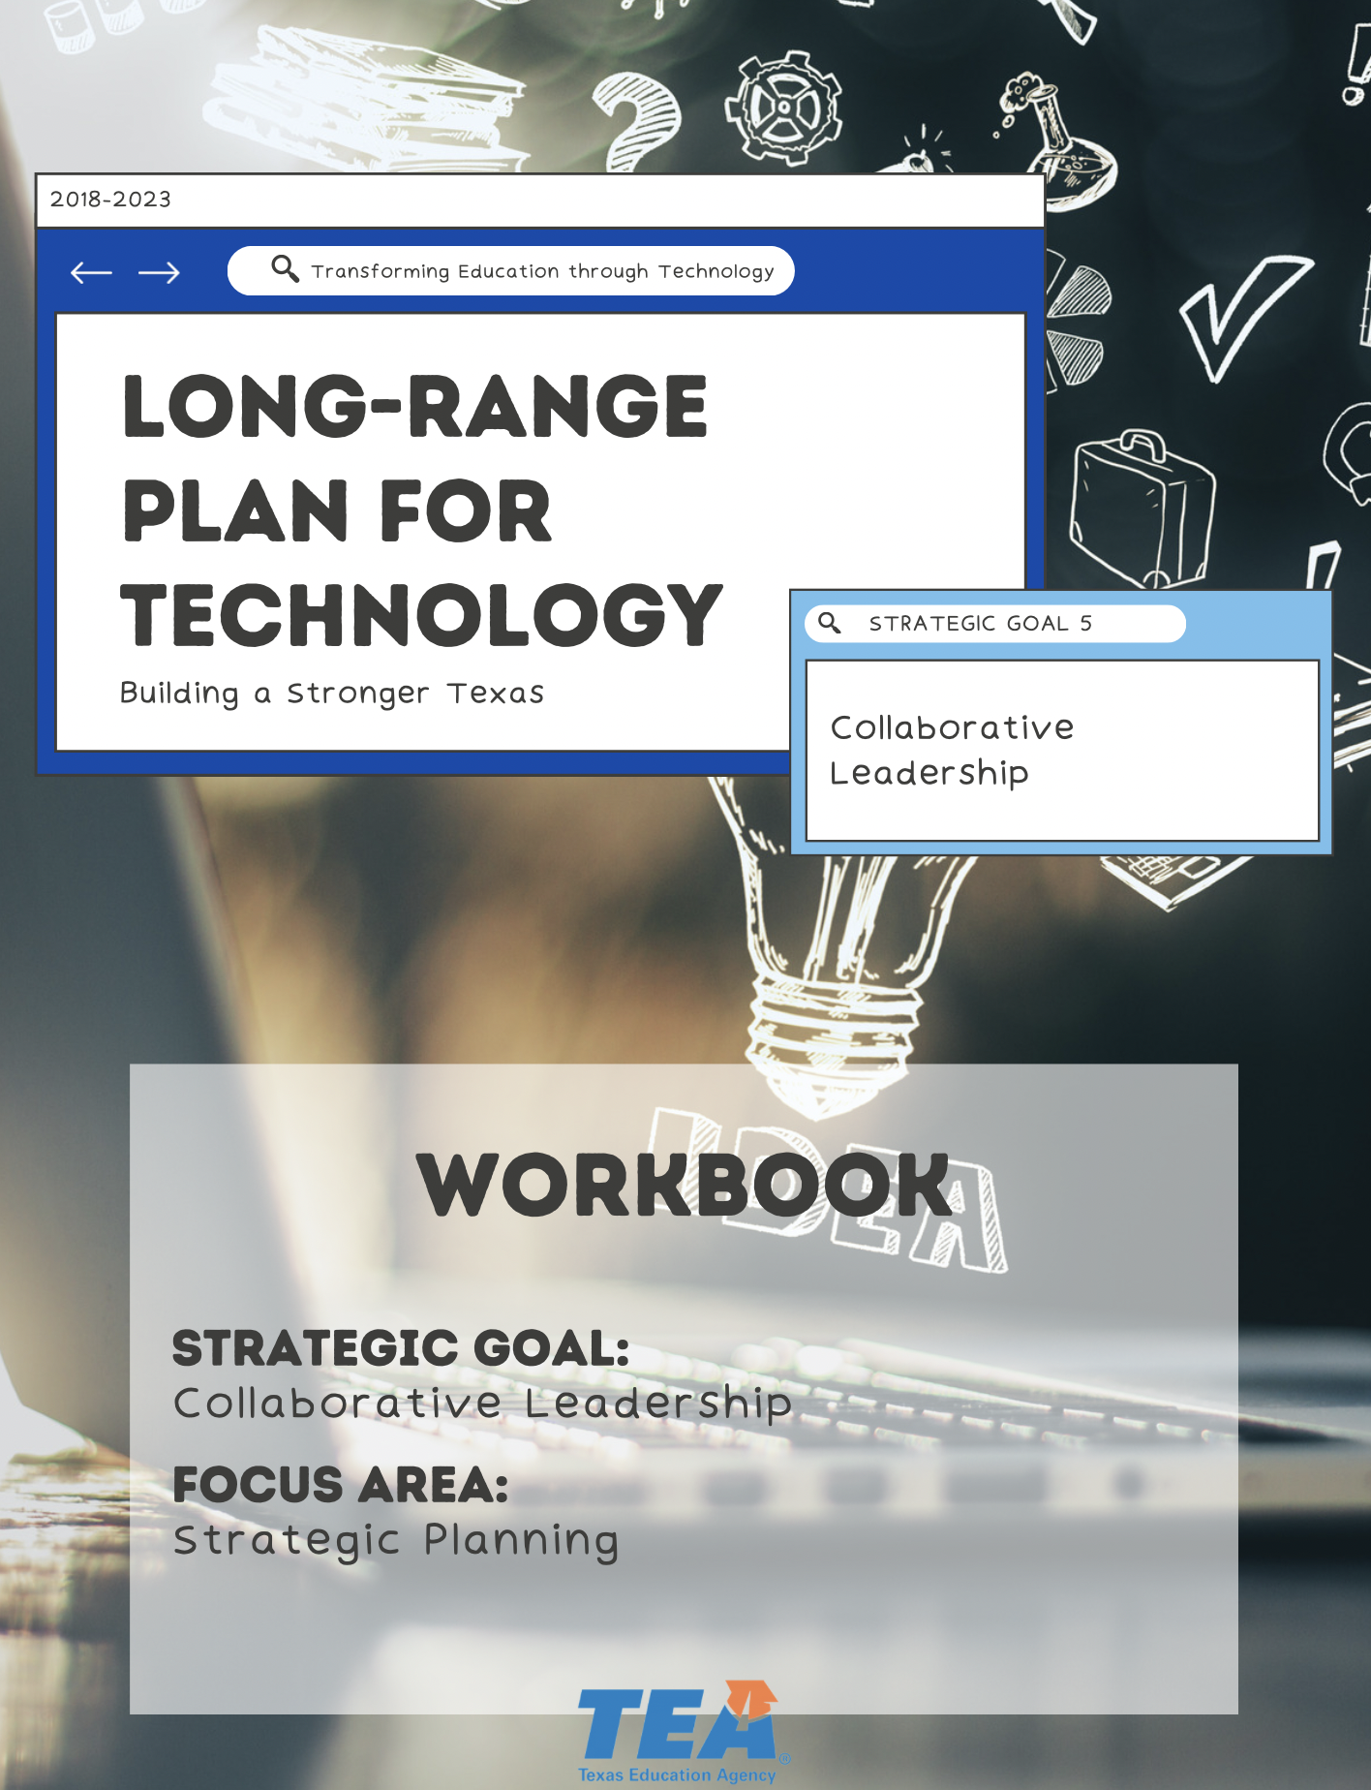
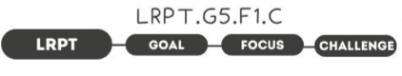

1. Take Note & Reflect:
Reflect on your district. Do you feel like the divisions of the district are siloed? How are leadership groups working together to ensure clear and unified vision ownership?

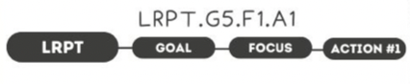
1. Take Note & Reflect:
How are all key stakeholders involved in strategic planning? How could you build upon involving key stakeholders in strategic planning for technology?

2. Take Note & Reflect:
How will you consider all aspects in one plan? What will consistent messaging in your district sound like?

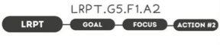

1. Take Note & Reflect:
Reflect on your district's clear vision. How can you incorporate technology in appropriate areas of the vision?

2. Take Note & Reflect:
How can your district develop measurable check points for success? What is in place to ensure stakeholders have ownership? How are compliance requirements incorporated in the plan with budget and staffing needs?

1. Take Note & Reflect:
How will your district evaluate effectiveness to make improvements?

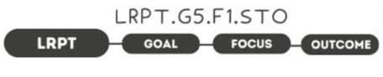

1. Take Note & Reflect:
What common goals will this plan allow stakeholders to work towards?

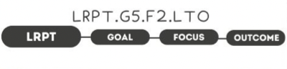

1. Take Note & Reflect:
What would optimizing costs allow your district to achieve? Reflect on what a proactive and efficient organization would look like and what it could help you achieve for students.

1. Take Note & Reflect:
Write a short summary statement for this focus area. How would you summarize what you've done and what you need to do for this focus area based on your work so far?

